TITLE

Subtitle

Extended abstracts should have 1000 to 1500 words.
They should include the following information: title, abstract, keywords, session that best fits into (metabolize & decarbonize, co-design & living, climate adaption & perform, materialize & build), main text (introduction, methodology, findings/conclusions) and references.
Extended abstracts can also contain figures, tables, and/or images, which are not included in the word count. Author/s and affiliation should not be included in the extended abstract submission, as they will be subject to a blind peer review process.
The file name should start with the session title, then the title of the paper.

ABSTRACT
Maximum 200 words
KEYWORDS
XXXXXXX (Maximum 5)

SESSION
XXXXX (Please choose one of the following: METABOLIZE & DECARBONIZE, CO-DESIGN & LIVING, CLIMATE ADAPTION & PERFORM, MATERIALIZE & BUILD)

1. MAIN TEXT
The main text of the Extended Abstract should include an introduction, methodology, and findings/conclusions.

The Extended Abstract should not exceed 1500 words including references. Page layout should be A4 (portrait orientation).

Extended Abstracts should be typed in Barlow Normal 11-point, single line spacing, with a blank line between each paragraph.

1.1 SECTIONS & SUB-SECTIONS
Sections should be used to make it easier to follow the paper. Section and sub-section titles should be numbered consecutively and typed in Barlow Normal 11-point, bold, with single line spacing before and after the title.

1.2 TABLES AND FIGURES
Table and figures should be inserted in the relevant part of the paper. Tables and figures should be referenced in the text (Table 1). Also, tables and figures should be numbered consecutively in accordance with their appearance in the text.

Period | Housing Typology
… | …
… | …
.... | …

Table x. Caption

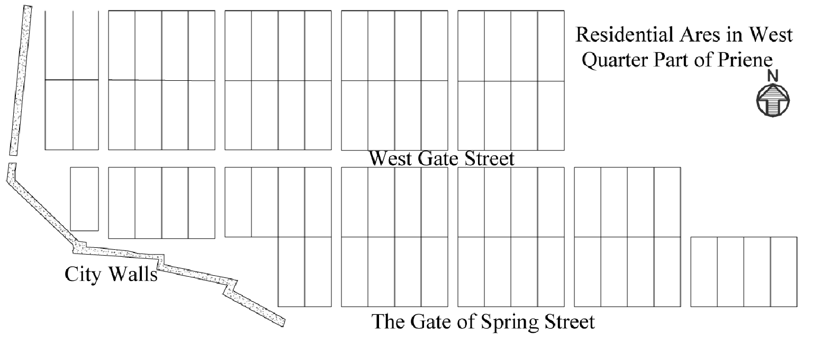

Figure x. Caption

1.3 FINDINGS/CONCLUSIONS
The results or main findings of the research should be clearly presented.

2. REFERENCES
References to all publications cited in the text should be presented in a list following the abstract body text. These should also be typed in Barlow Normal 11-point, single line spacing, bulleted.

- Baron, D.P., 2008. Business and the organisation. Chester: Pearson.
- Silverman, D.F. and Propp, K.K. eds, 1990. The active interview. Beverly Hills, CA: Sage.
- Samson, C., 1970. Problems of information studies in history. In: S. Stone, ed. Humanities information research. Sheffield: CRUS, pp. 44-68.
- Boughton, J.M., 2002. The Bretton Woods proposal: an indepth look. Political Science Quarterly, 42(6), pp.564-78.
- International Transport Forum, 2010. Transport Outlook 2010: The potential for innovation. [online] Available at: <http://www.internationaltransportforum.org/Pub/pdf/10Outlook.pdf>
[Accessed 2 September 2011].

The Harvard system of referencing is to be used. When making reference to an author’s work in the text, their name is followed by the year of publication of their work in brackets. If reference is made without mentioning the author in the text then both the author’s name and publication year are placed at the relevant point in the sentence or at the end of the sentence in brackets (Cormack, 1996). When more than one work is cited, these can be listed within the same bracket separated by a semi-colon and in chronological order (Cormack, 1996; Black, 2001). If page numbers are to be added, (required for quotations) this is to be done after a comma after the year followed by p. for a single page and pp. for a range of pages (Smith, 1978, pp.12-14).
Please make sure that every reference cited in the text is also present in the reference list.

